**Project Report**

Delete File Sequence Diagram:

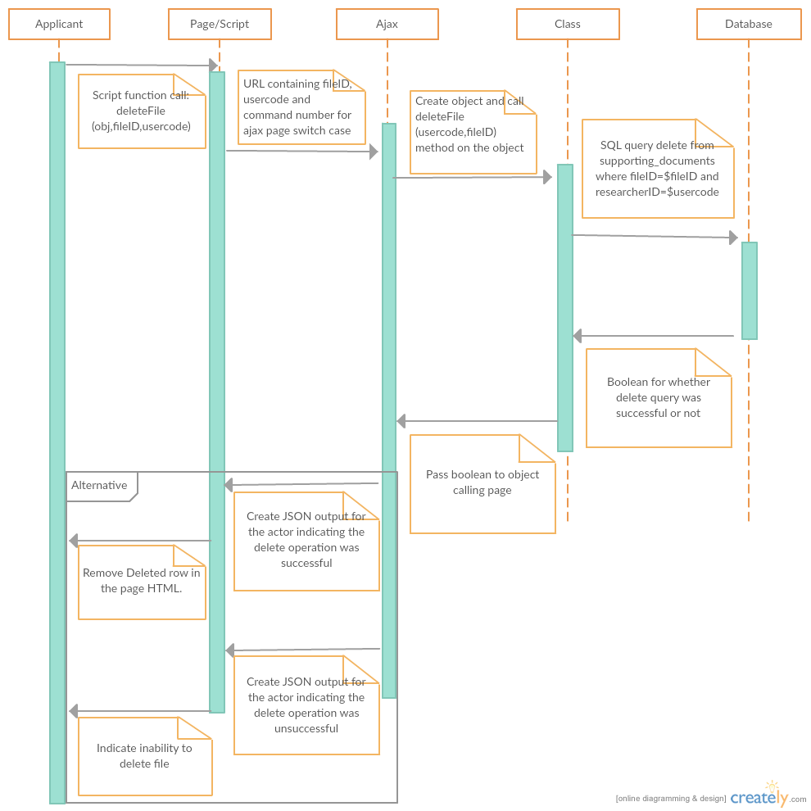

Unit Testing:

|  |  |  |
| --- | --- | --- |
| Unit Test Point | Testing | Result |
| Connect function in adb | Create an object of userFiles that extends adb and call a function of userFiles on it.  Test input: $obj-> getUserFiles (1)  Expected Result: Successful connection | Connection to the database was successful |
| Connect function in adb | Php unit test testADB  Test input: $obj-> Connect()  output: true  Assertion Condition: true if (true and $obj-> Connect()) | Connection to the database was successful |
| query function in adb | Create an object of userFiles that extends adb and call a function of userFiles on it.  Test input: $obj-> getUserFiles (1)  Expected Result: query should return true | query returns true |
| query function in adb | Php unit test testADB  Test input: select * from supporting_documents  output: true  Assertion Condition: true if (true and $obj-> query()) | query returns true |
| Fetch function in adb | Create an object of userFiles that extends adb and call a function of userFiles on it.  Test input: $obj-> getUserFiles (1)  Expected Result: records from the database specified in query | Specified Records called by getUserFiles |
| fetch function in adb | Php unit test testADB  Test input: $obj-> fetch()  output: true  Assertion Condition: true if (true and $obj-> fetch()) | Specified Records called by getUserFiles |
| SQL query in deleteFile function in userFiles | Run the query in phpmyAdmin to confirm the accuracy of the query  Test input: delete from supporting_documents where file_id=1 and researcher_id=1  Expected output: “1 rows affected” | File successfully deleted in phpmyAdmin |
| SQL query in getUserFiles function in userFiles | Run the query in phpmyAdmin to confirm the accuracy of the query  Test input: select filename, file_id from supporting_documents where researcher_id=1  Expected output: “showing 0-3 rows” | Files successfully retrieved in phpmyAdmin |
| getUserFiles function in userFiles | Create an object of userFiles and call getUserFiles on it.  Test input: $obj-> getUserFiles (1)  Expected output:true | Returned true |
| getUserFiles function in userFiles | Php unit test testUserFiles  Test input: $obj-> getUserFiles (1)  output: true  Assertion Condition: true if (true and $obj-> getUserFiles (1)) | returned true |
| deleteFile function in userFiles | Create an object of userFiles and call deleteFile on it  Test input: $obj-> deleteFile (1,1)  Expected output: True | Returned true |
| deleteFile function in userFiles | Php unit test testUserFiles  Test input: $obj-> deleteFile (16,1)  output: true  Assertion Condition: true if (true and $obj-> deleteFile (16,1)) | returned true |
| deleteFile() in usersajax.php | Test input: Click the delete button on the user interface and reload the page.  expected output: The file should be absent from the reloaded page | The reloaded page did not contain the deleted file |
| deleteFile() in usersajax.php | Test input: Click the delete button on the user interface and click yes to the confirmation message.  Expected Output: The page should display a popup message indicating the status of the delete operation generated from the JSON output of the deleteFile function. | The page displayed a popup message indicating the status of the delete operation. |
| URL in deletefile(obj,uc,fid) function in script on deleteajax.php page. | Php unit test test  Expected result:  Ok. 1 Test. 1 Success | 1 Assertion. 1 Failure |
| deleteFile(obj,usercode,fileID) on deleteajax.php | Test input: Click the delete button on the user interface  Expected Output: The page should display a pop-up asking whether you are sure you want to delete the file. | The page displays the confirmation popup |
| deleteFile(obj,usercode,fileID) on deleteajax.php | Test input: Click the delete button on the user interface and reload the page.  expected output: The deleted file should be absent from the reloaded page | The reloaded page did not contain the deleted file |
| deleteFileComplete(xhr,status) in deleteajax.php | Test input: Click the delete button on the user interface and click yes to the confirmation message.  Expected output: the page should display an alert indicating the status of the file delete operation. | The page displays an alert indicating the status of the file delete operation. |
| deleteFileComplete(xhr,status) in deleteajax.php | Test input: Click the delete button on the user interface click yes to the confirmation message and reload the page.  Expected Output: The deleted file should be absent from the reloaded page. | The deleted file is absent from the reloaded page. |

Professional Testing:

Tester: David Inusah

Functional Requirement: File Upload (by Hudson Lekunse)

The functional requirement implemented allows users to upload supporting consent forms at the end of the of their application process. The functionality is supposed to enforce two main constraints on the upload of files into the system; only files of size 5mb and below and of format pdf, txt, docs, xlsx. As required, these constraints are upheld and only files that qualify are uploaded. For all other files that do not qualify, an error message is generated that says, “Wrong file extension”. Also the functionality ensures that for every submission an applicant makes, there can be only one document uploaded for it.

Ajax Implementation Log:

|  |  |  |
| --- | --- | --- |
| Date | Duration | Time Spent |
| 14th April 2016 | 5pm-6:30pm | 1hr 30 mins |
| 21nd April 2016 | 6:30pm-8pm | 1hr 30 mins |
| 22nd April 2016 | 10am-9pm | 11hrs |
| 24th April 2016 | 11am-12pm | 1 hr |
| 25th April 2016 | 1pm-5pm | 4 hr |
| Total | | 19hrs |